“DESIGN AND ANALYSIS OF SUB-6GHZ ANTENNAS”
MINOR PROJECT REPORT
BACHELOR OF TECHNOLOGY
IN
ELECTRONICS AND TELECOMMUNICATION ENGINEERING
SUBMITTED BY
ANSHUMAN SINGH BHADORIA (0901ET221007)
DISHA PAL (0901ET221021)

UNDER THE SUPERVISION AND GUIDANCE OF
PROF. DEEP KISHORE PARSEDIYA
ASSISTANT PROFESSOR

DEPARTMENT OF ELECTRONICS ENGINEERING

JULY - DEC 2024

DECLARATION BY THE CANDIDATE

We hereby declare that the work entitled “DESIGN AND ANALYSIS OF SUB-6GHZ ANTENNAS” is our work, conducted under the supervision of PROF. DEEP KISHORE PARSEDIYA, ASSISTANT PROFESSOR, during the session Jul-Dec 2024. The report submitted by us is a record of bonafide work carried out by us.
We further declare that the work reported in this report has not been submitted and will not be submitted, either in part or in full, for the award of any other degree or diploma in this institute or any other institute or university.

ANSHUMAN SINGH BHADORIA

0901ET221007

DISHA PAL

0901ET221021

Date: 21/11/2024
Place:Gwalior This is to certify that the above statement made by the candidates is correct to the best of my knowledge and belief.

Guided By Approved by HoD

Prof. Deep Kishore Parsediya Dr. Vandana Vikas Thakre
Assistant Professor Professor
Department Of Electronics Engineering Department of Electronics Engineering
MITS Gwalior MITS Gwalior

PLAGIARISM CHECK CERTIFICATE

This is to certify that we, the students of B.Tech. in Department of Electronics Engineering, have checked our complete report entitled “DESIGN AND ANALYSIS OF SUB-6GHZ ANTENNAS” for similarity/plagiarism using the “Turnitin” software available in the institute.

This is to certify that the similarity in our report is found to be …… which is within the specified limit (30%). The full plagiarism report along with the summary is enclosed.

--------------------------------

ANSHUMAN SINGH BHADORIA

0901ET221007

DISHA PAL

0901ET221021

Checked & Approved By:

--------------------------------
Prof. Deep Kishore Parsediya
Assistant Professor
Department Of Electronics Engineering
MITS, Gwalior

ABSTRACT

The study focuses on the design, simulation, and analysis of an S-band microstrip patch antenna (MPA) for wireless applications. The substrate materials employed were FR-4 (lossy) and copper (annealed), both with dielectric permittivities of 4.3. The simulation is carried out using the computer simulation technology (CST) Suite Studio 2018 programme. In simulations, the return loss was -40dB, the gain was 3.726 dBi, the directivity was 7.525 dBi, the voltage standing wave ratio (VSWR) was 1.021, the bandwidth (BW) was 205-275 MHz, and the overall efficiency was 49.51%. The fundamental goal of this antenna is to have a minimal return loss while achieving as close to a VSWR of one as feasible when compared to other antennas; this will improve the antenna's gain, directivity, and efficiency.

ACKNOWLEDGEMENT

We would like to thank Prof. Deep Kishore Parsediya, Department of Electronics Engineering, Madhav Institute of Technology and Science, Gwalior. His skills and expertise in the field of antenna are much acknowledged. His ongoing encouragement and motivation prompted us to pursue research in microstrip patch antennas.

--------------------------------

ANSHUMAN SINGH BHADORIA

0901ET221007

DISHA PAL

0901ET221021

CONTENT

Table of Contents

Declaration by the Candidate 2
Plagiarism Check Certificate 3
Abstract 4
Acknowledgement 5
Content 6
List of Figures 7
Chapter 1: Introduction 9
Chapter 2: Literature Survey 12
Chapter 3: Parameters 13
Chapter 4: Comparison of 5.8ghz antenna research projects 18
Chapter 5: Result 22
Chapter 6: Conclusion 23
References 24

LIST OF FIGURES

5.8 GHz Antenna 10
Components of 5.8GHz Antenna 10
Directivity of 5.8GHz Antenna 13
Gain of 5.8GHz Antenna 14
S-parameter of 5.8GHz Antenna 15
Radiation pattern in 1-D of 5.8GHz Antenna 15
Radiation pattern in 2-D of 5.8GHz Antenna 16
Radiation pattern in 3-D of 5.8GHz Antenna 16
VSWR of 5.8GHz Antenna 17
Efficiency of 5.8GHz Antenna 17
Comparing Our Success In 5.8ghz Rectangular Microstrip Patch Antenna Research to Other Individual's 5.8ghz Rectangular Microstrip Patch Antenna Research Projects 18
Result Analysis In 5.8ghz Antenna And 1x4 Array Antenna 22

CHAPTER 1: INTRODUCTION

Wireless Technology and the Role of Microstrip Patch Antennas
Wireless technology has seen significant advancements, profoundly impacting modern life. Its applications span numerous devices, including the development of 5G mobile systems. Among these, microstrip patch antennas are highly suitable for 5G due to their enhanced efficiency, low power consumption, higher gain, and wider bandwidth. These antennas are integral to wireless systems, facilitating the transmission and reception of electromagnetic waves.
Overview of Rectangular Microstrip Patch Antennas
A Microstrip Patch Antenna consists of four primary components: the patch, ground plane, substrate, and feed mechanism. The radiating element, or patch, is a thin conductive strip positioned on one side of a non-conductive substrate, while the ground plane, made of similar material, is located on the opposite side. These antennas are lightweight, compact, and versatile, adaptable to both flat and curved surfaces. Their small size and ease of installation make them ideal for diverse applications. Furthermore, they are cost-efficient and can be easily fabricated using modern printed circuit board (PCB) technologies.
Applications of Rectangular Microstrip Patch Antennas
Due to their compact design and high efficiency, microstrip patch antennas are widely used in various communication systems. They are integral to mobile phones, Wi-Fi routers, and WLAN access points. Their functionality extends to satellite communications, military applications, CubeSats, small satellites, and remote sensing systems. These antennas offer reliable performance, ease of integration, and excellent transmission capabilities, making them a preferred choice in these fields.
Design Structure of Rectangular Microstrip Patch Antennas
Microstrip patch antennas are constructed on dielectric substrates using materials such as FR-4, Rogers, or Teflon, where substrate thickness directly affects performance and bandwidth. Typically, the patch, often rectangular, is crafted from conductive materials like copper and printed on the substrate's surface. The patch’s shape and dimensions dictate the resonance frequency and radiation pattern, while the feed line's dimensions influence impedance matching and bandwidth. The ground plane, situated on the substrate’s underside, significantly affects the antenna’s radiation properties through its size and geometry.
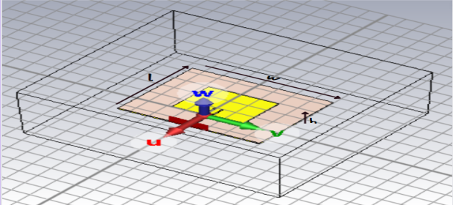
Fig. 5.8 GHz Antenna

COMPONENTS OF A PATCH ANTENNA
Radiating Patch: The key conductive component in a patch antenna, responsible for radiating or capturing electromagnetic waves.
Substrate: A dielectric material that provides mechanical support to the radiating patch while electrically isolating it. The substrate's thickness and dielectric properties significantly influence the antenna’s performance.
Ground Plane: A conductive layer positioned below the substrate, acting as a reference for the radiating patch and enhancing the antenna’s efficiency and functionality.
Feed Point: The junction where the antenna connects to the transmission line, delivering the necessary electrical signal to the radiating patch.
Microstrip Line: A slender conductive strip on the substrate that functions as the transmission pathway, linking the feed point to the radiating patch in the antenna.
Top of Form

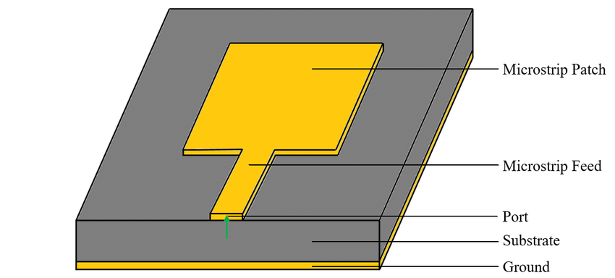

Fig. Components of 5.8GHz Antenna
Design Methodology of Rectangular Microstrip Patch Antenna
The design process for a microstrip patch antenna begins with selecting the appropriate operating frequency and substrate. For the proposed rectangular patch antenna, the resonant frequency is set at 5.8 GHz. Key parameters considered during the design include substrate thickness (h = 1.57 mm), resonant frequency (f = 5.8 GHz), and dielectric constant (𝑟 = 4.3), ensuring optimal performance of the antenna.

The width of the patch is calculated using the following equation:
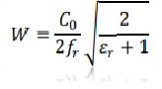
Here,
𝑊 = Width of the patch
Co= Speed of light
𝑟= value of the dielectric substrate

- The length of the patch is calculated using the following equation:
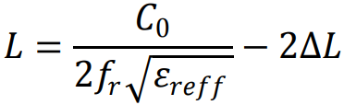
Here,
- L = Length of the patch
- Co= Speed of light
- 𝑟= value of the dielectric substrate

Result Discussion of Rectangular Microstrip Patch Antenna
Assess the antenna's impedance matching to ensure it aligns closely with the target impedance, typically around 50 ohms. Evaluate the antenna's bandwidth and confirm it meets the required specifications. Analyze the measured and simulated radiation patterns, verifying that the antenna radiates effectively in the desired direction and achieves the expected bandwidth. Assess the antenna's gain and compare it with the target gain specified in the design requirements. Confirm the antenna provides the intended polarization, whether linear, circular, or another type. Evaluate the overall efficiency of the antenna, considering factors such as radiation efficiency and losses within the conductive components and substrate. Analyze the impact of environmental factors, including temperature and humidity, on the antenna's performance. Investigate any variations in characteristics under different conditions.

CHAPTER 2: LITERATURE SURVEY

The body of research on 5.8 GHz rectangular microstrip patch antennas highlights their extensive utility in wireless communication systems. This is attributed to their compact size, lightweight design, and the simplicity of their manufacturing process. A review of the literature underscores the importance of these antennas in wireless communication, with various studies delving into their design methodologies, performance evaluation, and key parameters that influence their functionality. Researchers have also explored their applications across multiple domains and identified opportunities for performance enhancement by fine-tuning design parameters.
The radiating patch in these antennas is typically crafted from a conductive material like copper, which is printed onto the upper surface of the substrate. This design approach simplifies fabrication while maintaining performance. Rectangular microstrip patch antennas find widespread use in wireless local area network (WLAN) technologies, playing a pivotal role in devices such as Wi-Fi routers and access points. Their efficiency, combined with their adaptability to various configurations, makes them a cornerstone of modern wireless communication infrastructure.

CHAPTER 3: PARAMETERS

Directivity quantifies an antenna's ability to focus radiation in a specific direction and is defined as the ratio of the radiation intensity in a particular direction to the average intensity across all directions. This value is commonly expressed in decibels relative to isotropy (dBi), highlighting how effectively the antenna concentrates energy toward a desired direction. Higher directivity implies that the antenna efficiently radiates power in the targeted direction, enhancing signal transmission in that region. This characteristic is a key measure of the antenna's performance, distinguishing it from an ideal isotropic antenna that radiates energy uniformly in all directions.

The formula for directivity is given by:
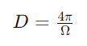
Here,
D is directivity
Ω is the solid angle subtended by the radiation pattern.
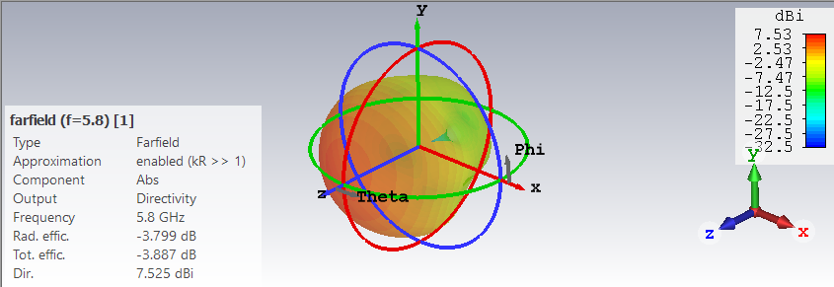
Fig. Directivity of 5.8GHz Antenna

GAIN OF RECTANGULAR MICROSTRIP PATCH ANTENNA
Gain, measured in dBi, indicates an antenna's ability to direct energy in a specific direction relative to an isotropic radiator. It represents the antenna's directional efficiency, with higher values denoting a more focused energy distribution. Conversely, a gain lower than that of an isotropic radiator indicates reduced efficiency in that particular direction. Directivity, defined as the ratio of the radiation intensity in a specific direction to the average intensity, has a direct relationship with gain. However, gain diminishes as the antenna’s bandwidth increases; a narrower bandwidth typically results in higher gain. The required gain depends on the specific application, helping determine the most suitable antenna for a given purpose.
The gain of a microstrip patch antenna can be calculated using the following formula:
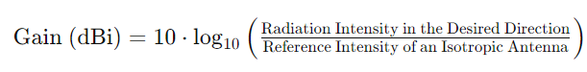
The gain can be expressed in terms of directivity:
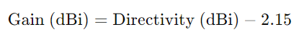
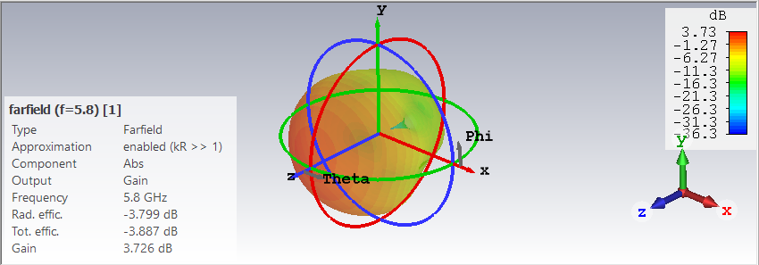
Fig. Gain of 5.8GHz Antenna

RETURN LOSS OF RECTANGULAR MICROSTRIP PATCH ANTENNA
Return loss is a key metric in antenna design, reflecting how effectively an antenna's input impedance aligns with the transmission line it is connected to. Expressed in decibels, it is calculated as the ratio of the power reflected back to the source to the power initially transmitted to the antenna. This metric serves as a measure of impedance matching, with a higher return loss indicating better matching, essential for efficient power transfer. Return loss typically varies with frequency, making it crucial to analyze the bandwidth over which the antenna operates with minimal return loss. It can be measured using network analyzers, while during the design phase, simulation tools like electromagnetic modeling software can predict return loss with precision.

The formula for return loss is given by:
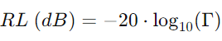
here:
RL is the return loss in decibels,
Γ (Gamma) is the reflection coefficient.

The reflection coefficient quantifies the relationship between the amplitude of the reflected wave and the amplitude of the incident wave:
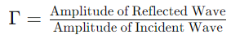
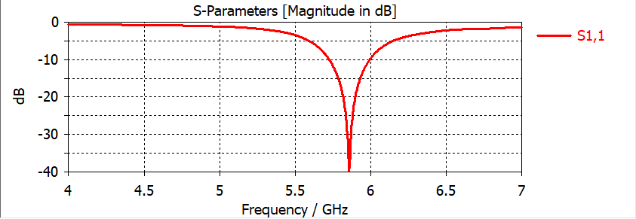
Fig. S-parameter of 5.8GHz Antenna

RADIATION PATTERN OF RECTANGULAR MICROSTRIP PATCH ANTENNA
The radiation pattern of an antenna represents how electromagnetic energy is distributed in space. It illustrates the variation in radiated power as a function of direction. This pattern is a critical factor in evaluating antenna performance and is typically described in terms of horizontal and vertical planes. An isotropic radiator serves as an idealized reference antenna, radiating energy equally in all directions in a perfect spherical pattern.
The gain of an antenna, when compared to an isotropic radiator, reflects its ability to concentrate power in a particular direction. The main lobe of the radiation pattern is the area where the majority of the radiated power is concentrated. Additionally, the radiation pattern reveals the polarization of the antenna, which can be either linear or circular. A 3D plot provides a comprehensive visualization of the antenna's radiation characteristics, offering insights into its azimuthal and elevation properties. This visualization aids in understanding the directional behavior and efficiency of the antenna.
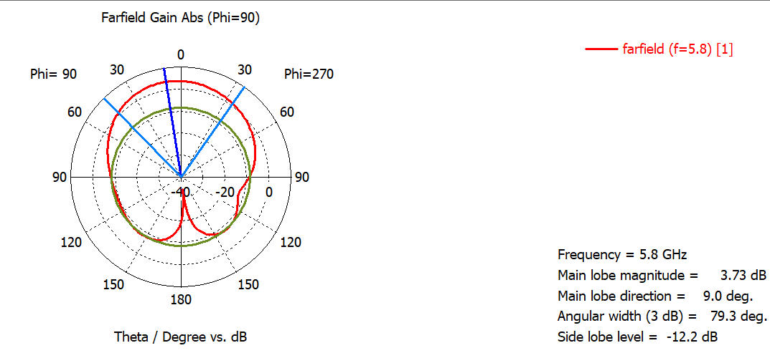
Fig. Radiation pattern in 1-D of 5.8GHz Antenna
VOLTAGE STANDING WAVE RATIO OF RECTANGULAR MICROSTRIP PATCH ANTENNA
The Voltage Standing Wave Ratio (VSWR) is an important indicator of the efficiency with which radio-frequency power is transmitted from a source to an antenna through a transmission line. It measures voltage fluctuations along the transmission line by comparing the signal's maximum and minimum voltage points. When the source and load impedances are perfectly matched, no reflection occurs, resulting in optimal transmission. In this ideal scenario, a well-tuned antenna will have a VSWR of one, signifying that no power is reflected back to the source, thus ensuring maximum power transfer.
For the best transmission performance, the VSWR should fall between 1 and 2, with a value closer to one being ideal for optimal impedance matching.
- In this simulation for a 5.8 GHz frequency antenna for applications involving wireless networks, the voltage standing wave ratio is 1.021 .

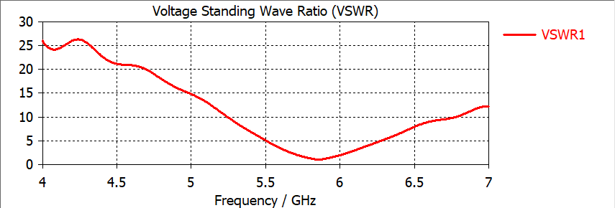
Fig. VSWR of 5.8GHz Antenna

RADIATION EFFICIENCY
The radiation efficiency of an antenna is determined by comparing its total power output to the net energy received from a connected transmitter. Specifically, for a rectangular microstrip patch antenna operating at 5.8 GHz, the radiation efficiency is recorded at-3.8.
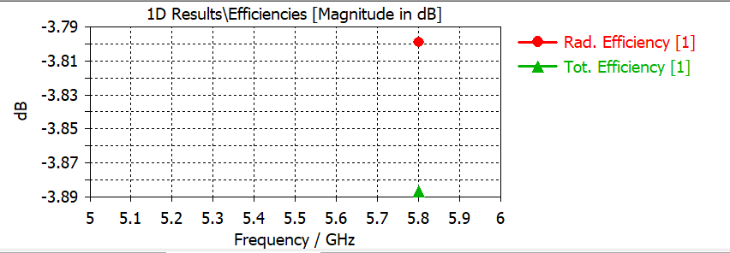
Fig. Efficiency of 5.8GHz Antenna

CHAPTER 4: COMPARISION OF 5.8 GHz RECTANGULAR MICROSTRIP PATCH ANTENNA RESEARCH PROJECTS

FREQUENCY | 5.8GHz | 5.8GHz | 5.8GHz | 5.8GHz
GAIN | 2.592dBi | 3.07dBi | 1.59 | 3.726dBi
DIRECTIVITY | 7.47dBi | 5.18dBi | 4.88 | 7.525dBi
S-PARAMETER VALUE (return loss) | -20.405dBi | -47.20 | -13.15 | -40
RADIATION EFFICIENCY |  | 1.57 |  | -3.8
BANDWIDTH | 0.0746GHz | 240 – 250Mhz | 200 – 250MHz | 205 – 275MHz
PATCH SIZE  (length × width × height) |  | 28mm × 36mm × 0.035mm | 38.03mm × 29.44mm | 15mm × 11.5mm × 0.035mm
SUBSTRATE TYPE | FR-4 (lossy) | FR-4 (lossy) | FR-4(lossy) | FR-4 (lossy)
SUBSTRATE SIZE  (length × width × height) |  |  | 47.636mm × 39.043mm | 70mm × 70mm × 1.57mm
FEED LINE  (length × width × height) |  | 12mm × 4mm × 0.035mm |  | 15.44mm × 3mm × 0.035mm
VOLTAGE STANDING WAVE RATIO (VSWR) | 1.221 | 1.05 | 1.56 | 1.021
DIELECTRIC PERMITIVITY | 4.3 | 4.3 | 4.3 | 4.3

Comparing Our Success In 5.8ghz Rectangular Microstrip Patch Antenna Research To Other Individual's 5.8ghz Rectangular Microstrip Patch Antenna Research Projects

CHAPTER 5: RESULT ANALYSIS

Result Analysis of 5.8GHz Antenna:
This study utilizes FR-4 (a lossy substrate) combined with copper as the patch material for simulating a 5.8GHz antenna intended for wireless communication applications. The simulation results show that the gain of the FR-4 substrate antenna is 3.726 dBi, with a directivity of 7.525 dBi. The return loss is measured at -40 dB, while the radiation efficiency is -3.8, and the total efficiency stands at 49.51%. The antenna exhibits a bandwidth ranging from 205 MHz to 275 MHz. The Voltage Standing Wave Ratio (VSWR) is calculated to be 1.021, and the dielectric permittivity of the substrate is 4.3.

CHAPTER 6: CONCLUSION

In conclusion, this study has provided significant insights into the performance and optimization of the 5.8 GHz rectangular microstrip patch antenna. The antenna exhibits a gain of 3.726 dBi, a directivity of 6.771 dBi, and a return loss of -42. The radiation efficiency is measured at -3.616, while the total efficiency stands at 46.58%. The bandwidth spans from 2.409 GHz to 2.493 GHz, with a Voltage Standing Wave Ratio (VSWR) of 1.015, and a dielectric permittivity of 4.3. The performance of the proposed antenna demonstrates exceptional characteristics across key parameters, including S-parameters, gain, efficiency, and beam-steering capabilities. The validation of these results is based on both experimental and simulated data, effectively confirming the antenna's practical suitability for 5G applications.

REFERENCES

- M. K. Aghwariya and A. Kumar, “Microstrip Patch Antenna Techniques for Wireless Applications,” in Microstrip Antenna Design for Wireless Applications, 1st ed., Boca Raton: CRC Press, 2021, pp. 3–12.
- A Review Paper on Microstrip Patch Antenna (MPA) for 5G Wireless Technology by Praveen Kumar Patidar and Nidhi Tiwari, Department of Electronics and Communication Engineering, Sagar Institute of Research & Technology (SIRT), SAGE University, Indore.
- A 5.8 GHz Microstrip Antenna with Harmonics Suppression Capability Using Defected Ground Structure by Shaharil Mohd Shah, M. Mohamad, S. A. Hamzah, Z. Z. Abidin, F. C. Seman, N. Katiran, H. A. Majid, A. Ashyap, and S. Mohamad, Research Center for Applied Electromagnetics, Universiti Tun Hussein Onn Malaysia, Johor, Malaysia.
- Design and Analysis of Microstrip Patch Antenna for 5G Wireless Communication Systems by Md. Sohel Rana (Independent University, Bangladesh) and Md. Mostafizur Rahman (Khulna University of Engineering & Technology, KUET).
- Design of a Compact Rectangular Microstrip Patch Antenna for 5.8 GHz ISM Band by Rubaya Khatun, Mahfujur Rahman, and Abu Zafor Md. Touhidul Islam, Department of Electrical and Electronic Engineering, University of Rajshahi, Rajshahi, Bangladesh.
- A 5.8 GHz Microstrip Patch Antenna Design, Simulation, and Analysis for Wireless Applications by Professor Dr. Md. Mostafizur Rahman and Md. Shahriar Mahmud, Department of Electronics and Communication Engineering, Khulna University of Engineering and Technology, Khulna, Bangladesh.
- D. Prabhakar, P. Mallikarjuna Rao, and M. Satyanarayana, “Design and Performance Analysis of Microstrip Antenna Using Different Ground Plane Techniques for WLAN Applications,” International Journal of Wireless and Microwave Technologies, vol. 6, no. 4, pp. 48–58, 2016.
- R. K. Bajpai, R. Paulus, A. Singh, and M. Aneesh, “Review: Dual Band Microstrip Antennas for Wireless Applications,” International Journal of Advances in Applied Sciences (IJAAS), vol. 7, no. 2, pp. 143–151, Jun. 2018, doi: 10.11591/ijaas.v7.i2.pp143-151.
- A. Kaur and D. Parkash, “Design of Dual-Band Microstrip Patch Antenna with Chair Shape Slot for Wireless Applications,” International Journal of Engineering Research & Technology, vol. 6, no. 4, pp. 728–731, 2017.
- P. Swathi and N. Nazeeya Anjum, “Design of Microstrip Patch Antenna for 5.8GHz Wireless Applications,” Sri Sai Ram Engineering College, 2021.
- Miniaturized Dual-Band Dual-Mode Microstrip Patch Antenna with Defected Ground Structure for Wearable Applications by Nur Azura Shamsudin and Shaharil Mohd Shah, Faculty of Electrical and Electronic Engineering, Universiti Tun Hussein Onn Malaysia.

